**North South University**



**Department of ELECTRICAL AND COMPUTER SCIENCE**

**PROJECT PROPOSAL**

**COURSE: CSE-499-A**

**SECTION-14**

**GROUP-1**

PROJECT TITLE: GARBAGE COLLECTOR ROBOT

Supervised BY: Dr. Shazzad Hosain

**SUBMITTED BY-**

|  |  |
| --- | --- |
| **NAME** | **ID** |
| **FARJANA ALAM** | **1620060042** |
| **MOIN SHAHRIYAR** | **1610586042** |
| **SARHAN OSMAN BHUIYA** | **1611008042** |

**ABSTRACT**

We are presenting a smart robot that could present a viable solution towards efficient waste management which is based on embedded, digital image processing. The system is designed so that it can automatically detect and collect the garbage. This proposal report describes the basic idea of detection and collection. The detection is done by using the image processing algorithm and the collection is done by the robot. Raspberry pi camera will capture an image of a particular area, and will store it as default image. Once an object has been detected, the camera will capture its image. It will identify the object as garbage, and then further send the signals to the robot. Our robot will calculate its position, calibrate the motors according to the position of the garbage so that it will go to the acquired position and collect the garbage. Once the dustbin is filled up to a certain limit, the level sensor in the bin will sense the level of the garbage and send it to the nearest garbage collector truck or bin.

**PROBLEM STATEMENT**

Bangladesh is the ninth most populous and twelfth most densely populated country in the world. With this population growth, there is an increasing problem of waste management particularly in the larger cities. Currently, according to an UNFPA report, Dhaka is one of the most polluted cities in the world and one of the issues concerned is the management of municipal waste. Current (2019) waste generation in Bangladesh is around 22.4 million tons per year or 150 kg/cap/year.[1] There is an increasing rate of waste generation in Bangladesh and it is projected to reach 47,064 tons per day by 2025. The rate of waste generation is expected to increase to 220 kg/cap/year in 2025. A significant percentage of the population has zero access to proper waste disposal services, which will in effect lead to the problem of waste mismanagement. The total waste collection rate in major cities of Bangladesh such as Dhaka is only 37%. When waste is not properly collected, it will be illegally disposed of and this will pose serious environmental and health hazards to the Bangladeshis. [2]

One of the most adverse impacts of poor waste management, especially municipal waste, is the incidence and prevalence of diseases such as malaria and respiratory problems, as well as other illnesses through the contamination of ground water. Biomedical wastes pose great danger in Bangladesh too as a report estimated that 20% of the biomedical waste is "highly infectious" and is a hazard since it is often disposed of into the sewage system or drains.[3] With regards to the living standards, solid waste leads to blockage in the drainage system which leads to flooding in the streets. Consequently, mosquitoes and bad odor are among the negative impacts resulted. [4] The main objective of this project is to recognize and categorize the waste autonomously, which require minimal human intervention. The robot will collect waste categorizing them as Plastic, Paper, Glass and Metal and put them in a container.

**LITERATURE REVIEW**

There are numerous methods that are used to make a garbage collecting robot. These methods provide the information about various techniques used for a garbage collecting robot. Some of these methods do have limitations which are proposed in this section.

In the first method, as a solution to manual primary waste disposal, a cost effective garbage cleaning robot is developed and that is named as “Thooyan”[5]. The system (road cleaning robot) consists of very simple but highly efficient mechanism. The main components consist of a rotating brush assembly (rake), a unique tilting wedge, a conveyor system and a garbage collection unit. Robot is programmed in a certain pattern so as to navigate automatically and detect obstacles to move in a free path. If encountered by a moving obstacle, the robot is programmed to pause for duration of 50 seconds and then sense again to move or it will take turn of 180 degree. A solar panel is provided for partial charging of the battery. Since this robot uses conveyor belt the cost of the whole system will be more which adds limitation to this method. But it gave an idea or advantage to use solar panels which in turn helps to reduce the power consumption. This robot is the small step to change the manual waste collection and ensures the safety of sanitary workers.

The second robot is about cleaning robot for the swimming pools, the house, the wall and the domestic stairs are interested and developed continually but the cleaning robot for the beach does not be much interested. Therefore, this paper presents the development of a prototype garbage collection robot on the beach. [6] This robot uses the Bluetooth for communication between the user and the robot. The robot is built on the caterpillar wheels, and the power is supplied from 12V 30Ah battery which is connected to 40W solar cells. In addition, it is also equipped with an IP camera with added pan/tilt capabilities which relays feedback information to the human operator via Ad-hoc system. The results of robot performances were found that the robot can move with an average speed of 0.5 meters per second on the sand via wireless communication and collect the big garbage with side 12.5 x 49 cm, for example, glass bottles, and plastic.

The robot, called ROAR [7] is transported to the refuse collection site on the back of a refuse truck. An operator presses a button on the truck and this prompts a drone to be launched from its roof and begin scanning the surrounding area to locate bins. The locations of the bins are then relayed to the ground-based robot. ROAR navigates its way to each bin using a map of the area and the likely locations of bins, as well as the data provided by the drone. GPS and LiDAR are used to help it navigate and avoid obstacles. Inertial measurement unit (IMU) data, from accelerometer and gyroscope sensors, are used to help the robot keep track of its position. Once ROAR has arrived at the bin, it uses cameras and LiDAR to position itself, before extending its arms and lifting the bin onto its built-in platform. It then returns to the refuse truck and lifts the bin into position to be emptied. Manual intervention is needed which is the demerit.

**PROPOSED SOLUTION**

The proposed system concentrates on identification, classification and segregation of waste. The waste, which is in unsorted manner, is dumped in a landfill, which further creates hazardous health problems. The proposed system aims to recognize and categorize the waste autonomously, which require minimal human intervention. This entire process of recognition of waste material is based on the shape and size of the objects.

The system will be trained through datasets by using machine learning technique such as SINGLE SHOT DETECTION (SSD). Utilizing Raspberry Pi the characterization result will be given to the equipment part of the framework with the goal that it will be dumped in its separate containers. The system will collect waste automatic categorizing them as Plastic, Paper, Glass and Metal. The collection part will be done by the robot. As the system works independently, there is no need of human mediation to control or to do any assignment.

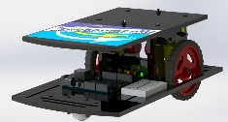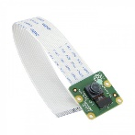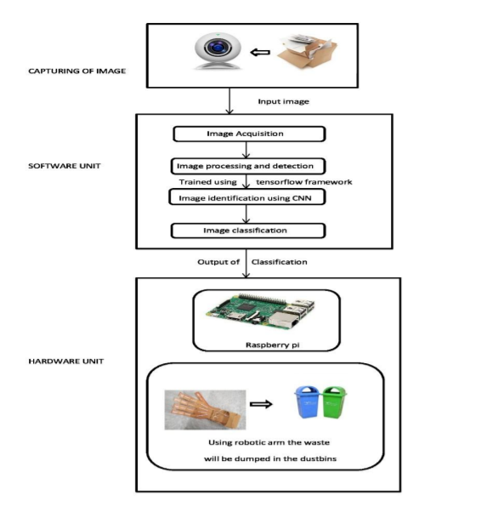

Fig: Process of Garbage Collection

**BRIEF WORK PLAN**

Our project is basically the idea of detection and collection. The detection part will be done by the Raspberry Pi and the collection part will be done by the robot. As a result, we have divided our project into two major parts.

1. **PROJECT WORK IN 499-A (DETECTION)**

The first stage is image acquisition stage. It catches image from camera with the goal that it can be passed for handling and recognition of picture. After picture has been saved, different strategies for handling can be connected to the picture to perform a wide range of vision undertakings. After analyzing, the image is processed and detected. The system is trained using Tensor flow framework. By relying on large datasets, the framework can recognize the picture and plan significant labels and classifications. The trained data is used to classify the waste into Plastic, Paper, Glass and Metal. Raspberry pi camera will capture an image of a particular area, and will store it as default image. Once an object has been detected, the camera will capture its image. It will identify the object as garbage, and then further send the signals. The edge detection algorithm is used for the differentiation of the scattered edges and compact and collinear edges of the garbage.

**SETTING UP RASPBERRY PI**

* **Update the Raspberry Pi**
* **Install TensorFlow**
* **Install OpenCV**
* **Compile and Install Protobuf**
* **Set up TensorFlow directory structure**
* **Test out object detector**

1. **PROJECT WORK IN 499-B (COLLECTION)**

The idea of garbage collection has immensely aided in keeping the environment clean. Automated Garbage Collector is a driverless autonomous vehicle specifically designed to collect waste. Once the waste is collected, it would go back to its base position autonomously. The bin status is also maintained.

**CREATING THE ROBOT**

* **Collect Components Required**
* **Construction of Basic Structure of the Robot**
* **Circuit Connections**
* **Interfacing Servo Motor**
* **Interfacing Sonar Sensor for Avoiding Obstacles**
* **Testing Robot**

**FLOWCHART**

INITIALIZATION

(Start Pi Camera)

Capture Frame

Is Garbage Detected?

NO

YES

Is Garbage Infront of an obstacle?

YES

NO

Robot Changes

Position

Pick the Garbage

Categorize Garbage as Plastic, Paper, Glass or Metal

Put Garbage in

Separated Bins

**MAJOR MILESTONES**

The proposed research and development project is expected to achieve following milestones.

1. Set up Raspberry Pi with TensorFlow
2. Collect garbage images for dataset
3. Label all garbage images as Plastic, Paper, Glass and Metal
4. Create a dataset with collected images
5. Code the software
6. Train the system to detect garbage’s
7. Setup the structure of the robot
8. Create arms for the robot to collect detected garbage
9. Make separate bins for collecting garbage which a specifically categorized
10. Make a final report of the effectiveness

**BUDGET**

Our budget might change according to further requirements in the project. Prices may also vary based on wholesale products. Overall, a tentative budget plan is given below:

|  |  |
| --- | --- |
| Components | Report price |
| Raspberry pi 3 B+ | 3850 |
| Pi Case | 430 |
| Memory card | 550 |
| Heat sink | 50 |
| Sonar(4) | 90*4=360 |
| Robot car chassis | 800 |
| Robotic arm with  Servo Motor | 5500 |
| Arduino UNO | 350 |
| Arduino MEGA | 700 |
| Motor shield | 300 |
| Power bank 2 | 1100*2=2200 |
| Pi Camera | 1000 |
| Other Components | Pending |

**REFERENCES**

1. <http://www.atlas.d-waste.com/>
2. <http://wasteconcern.org/Publication/Waste%20Survey_05.pdf>
3. <http://www.apo-tokyo.org/publications/files/ind-22-swm.pdf>
4. <https://www.daily-sun.com/printversion/details/346071/2018/10/28/Waste-Management-in-Bangladesh>
5. <http://www.ijfcc.org/papers/329-CS3004.pdf>
6. <http://www.citylab.com/tech/2016/03/the-robot-garbage-collectors-are-coming/471429/>
7. <http://www.ipcbee.com/vol66/019-IEEA2014-A044.pdf>
8. <https://github.com/tensorflow/models/tree/master/research/object_detection>
9. <https://github.com/topics/object-detection>
10. <https://github.com/bourdakos1/Custom-Object-Detection>
11. <https://www.tensorflow.org/lite/models/object_detection/overview>
12. <https://tensorflow-object-detection-api-tutorial.readthedocs.io/en/latest/training.html>
13. <https://github.com/EdjeElectronics/TensorFlow-Object-Detection-on-the-Raspberry-Pi>
14. <https://www.pyimagesearch.com/2017/10/16/raspberry-pi-deep-learning-object-detection-with-opencv/>